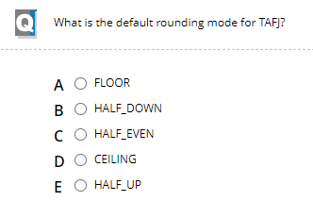

Ans: E

Ans: D

Ans: B

Ans: C

Ans: B

Ans: A

Ans: A

Ans: D

Ans: B

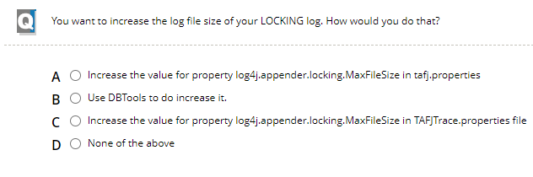

Ans:C

Ans: A

Ans: B

Ans: D

Ans: A

Ans: D

Ans: C

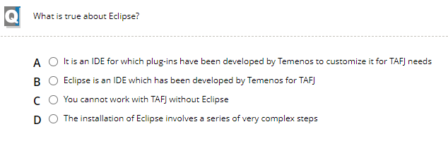

Ans: A

Ans: A

Ans: D

Ans: D

Ans: B

Ans: C

Ans: B

Ans: B

Ans: D

Ans: E

Ans: D

Ans: A

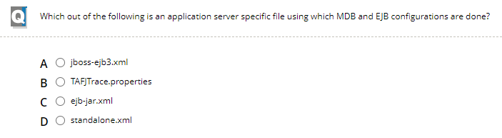

Ans: C

Ans: D

Ans: D

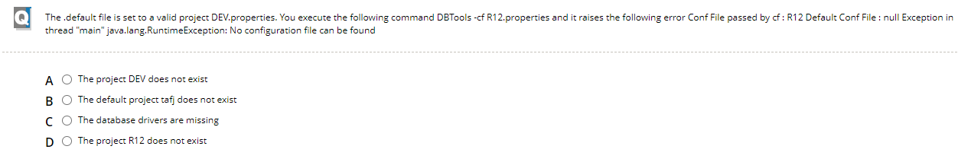

Ans: D

Ans: B

Ans: C

Ans: B

Ans: D

Ans: A

Ans: C

Ans: C

Ans: C